**Optimal Binary Search Tree**

A set of integers are given in the sorted order and another array freq to frequency count. Our task is to create a binary search tree with those data to find the minimum cost for all searches.

An auxiliary array cost[n, n] is created to solve and store the solution of subproblems. Cost matrix will hold the data to solve the problem in a bottom-up manner.

## Input and Output

Input:

The key values as node and the frequency.

Keys = {10, 12, 20}

Frequency = {34, 8, 50}

Output:

The minimum cost is 142.

These are possible BST from the given values.

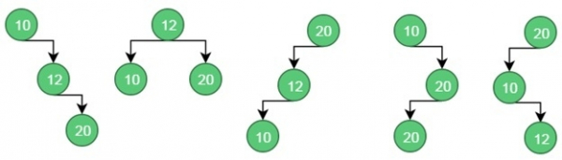For case 1, the cost is: (34*1) + (8*2) + (50*3) = 200

For case 2, the cost is: (8*1) + (34*2) + (50*2) = 176.

Similarly for case 5, the cost is: (50*1) + (34 * 2) + (8 * 3) = 142 (Minimum)

## Algorithm

optCostBst(keys, freq, n)

**Input:**Keys to insert in BST, the frequency for each key, number of keys.

**Output:** Minimum cost to make optimal BST.

Begin

   define cost matrix of size n x n

   for i in range 0 to n-1, do

      cost[i, i] := freq[i]

   done

   for length in range 2 to n, do

      for i in range 0 to (n-length+1), do

         j := i + length – 1

         cost[i, j] := ∞

         for r in range i to j, done

            if r > i, then

               c := cost[i, r-1]

            else

               c := 0

            if r < j, then

               c := c + cost[r+1, j]

            c := c + sum of frequency from i to j

            if c < cost[i, j], then

               cost[i, j] := c

         done

      done

   done

   return cost[0, n-1]

End

**RELEVANT READING MATERIAL AND REFERENCES:**

**Source Notes:**

1. <https://www.tutorialspoint.com/Optimal-Binary-Search-Tree>

**Lecture Video:**

1. <https://youtu.be/vLS-zRCHo-Y>

**Online Notes:**

1. <http://vssut.ac.in/lecture_notes/lecture1428551222.pdf>

**Text Book Reading:**

1. Cormen, Leiserson, Rivest, Stein, “*Introduction to Algorithms*”, Prentice Hall of India, 3rd edition 2012. problem, Graph coloring.

**In addition: PPT can be also be given.**